**Deli / Chicken Roll Web App Project**

**CIARAN ROCHE - G00376934**

**MILOSZ** **MILEWSKI - G00376658**

**Table of Contents**

1. **Introduction**
2. **System Requirements**
3. **Technology used and why**
4. **Design Methodology Applied**
5. **Features of the Implementation**
6. **Limitations and Known Bugs**
7. **Recommendations for Future Development**
8. **Conclusion**

**Introduction:**

For our project, we decided that we would implement the design of a chicken roll or deli app. We decided on a react application which is connected to an SQL database with a number of different tables. The app will allow the user to create an account, create a review of a deli, search reviews, search for delis, rate and like other reviews and delis. In this document we will talk about the system requirements, technologies used, design methodologies, features, limitations and bugs and finally recommendations for future development.

Our main objectives were as follows:

* Login system based on information stored in SQL
* Submit reviews
* Rate delis
* Search for delis
* Improve our teamworking skills
* Practise project management using different tools such as Jira
* Practise different aspects of project management by using the likes of:
* Sprints to complete stages
* Burndown charts on Jira
* Using GitHub to store documentation and the project
* Weekly meetings as a group and with our mentor
* Weekly documentation of our weeks progress

**System Requirements:**

As the project is still in early phases and not put online just yet. In order to run the project, you will need the following:

* Open a command prompt by typing cmd
* Clone the repository to your pc or desktop – git clone and the URL
* Install the required modules. You do this by typing npm install
* Then type npm start
* This is needed to be done for both the backend and the front end in order for it to run correctly
* The latest version of node needs to be installed along with an editor such as visual studio code

Once the website is made available online you will not need to follow the steps above as the user will be able to interact with it like any other website on the internet.

We will take you through the user’s perspective of the website in a heading below called features of the implementation.

**Technology Used and Why:**

Below is a list of technologies used. We will give a brief explanation as to why we chose each.

1. **JavaScript**

JavaScript is the language that we have decided to use as our programming language for the application. We chose this language as we both have good experience and enjoy immensely working with JavaScript. Secondly, it is a very simple and efficient language to use. There is lots of great resources to use with many different features that we can implement through JavaScript.

1. **React**

We decided to use a react application for the project. There were a number of reasons for choosing this. As part of semester one we studied react and both of us have a great interest in it. React seemed the most appealing route to take. Another reason for choosing this was due to our knowledge React. We both feel confident in our abilities to be able to use it. However, there is still a huge learning scope for us. There is a lot of new things we learned when working on the app. This made the application both rewarding and challenging.

1. **Tailwind CSS**

We used tailwind CSS as a way of designing the web application. We chose this as we found there was a lot of unique aspects to CSS that were superior to other designs. In terms of front end, it made the styling sleeker and very easy to use. It was very easy to implement as well.

1. **MySQL**

We decided that the best database management system is MySQL. We were originally looking at MongoDB but with all the different tables and relationships between said tables, MySQL was clearly the better option for us. We are also learning MySQL for a number of years, so it was very easy to implement and design.

1. **Jira**

We used Jira as our project management tool. We chose this as we felt it was the most useable and flexible tool available to us. We could set up sprints, we had a roadmap and backlog. It was also very useful for assigning people tasks. This tool is very useful as it was a guide as to where we are and where we should be on the project.

**Design Methodology Applied and Software Development Life Cycle:**

We started our project by having a meeting and setting out a timeline for the project. We did this by setting up a Jira board. We first set the project into 4 stages:

* Front end
* Database
* Backend
* Documentation

We used these as a basis for our sprints. We then decided on a design or possible design that we would pursue. We did this by creating some freehand designs and ultimately creating a wireframe. We decided to make 3 GitHub repositories. Front end, Back end and documentation repositories. This made it easier to separate out the work. The reasoning for separating the front end and back end was so that there was no clash between the front end and back end. Also, it was so that we could separate them in order to make the website go live.

*Sprint 1:*

We then proceeded to set up the front end. This was done by creating a react app. All the necessary modules were installed and the skeleton for the front end was ready. Setting up and designing the front end was our first sprint. The front-end sprint took approximately 2 to 3 weeks.

In this time, we created the design for:

* Login Page
* Register Page
* Home Page
* Map Page
* Submit a review Page

We collaborated with each other to get the design of the pages up and running. We discussed different designs and decided on the best one to use. Each of us took a page each to design and work over a few days in the week before our scheduled weekly meeting. The design of the front end was submitted to the GitHub repository for the front end.

*Sprint 2:*

Our second sprint was all based around the database. During this time, we designed the Entity Relationship Diagram and then set up the scripts for the SQL database. We both did this over meetings and collaborated to decide on the best design for the SQL tables. This sprint took in total around a week.

*Sprint 3:*

Our third sprint was for the Backend design of the project. This was probably the most complex part of the project with us learning a few new things as we went along. This was essentially were we set up the connection to the front end. We set up the skeleton for the project and then collaborated with each other and took different areas to proceed with. This was to link up the entire project and we could see real progress at this point. This was also the point where we updated how the SQL database works. Instead of having a script that created the table, the backend was designed in a way so that it generates it automatically. We will talk about this more in the features section below.

*Sprint 4:*

Our final sprint was where we made this document and tied up all the loose ends of the project. This was essentially where the bulk of the work was done but it was now time to clean it up, comment the code more efficiently and see the final submission of our project.

**Architecture of the solution and Features of the Implementation:**

Here we will give you a look at our project. We will talk about some of the aspects that a user can utilise, and we will also provide some screenshots of the project. (Note: this document is being written on the 16th of April. Some of the screenshots may look different to the final product but the outcome is still the same)

***Register:***

The first feature we would like to talk to you about is how the user is first greeted at the opening of the application/ website. This is the register page. In order for the user to fully access and utilise the project/ application, they must register an account. The user is asked to enter their:

* Email address
* Username
* Password
* Date of Birth
* Must tick the acceptance of terms and conditions

The details are then stored on the SQL server. There are a number of constraints such as:

* The email must be unique and a valid email address
* The username must be unique.
* The password must be a minimum of 5 characters and maximum of 60.

The error messages displayed show the constraints that must be met. Below you can see a number of images from the register page detailing all the above.

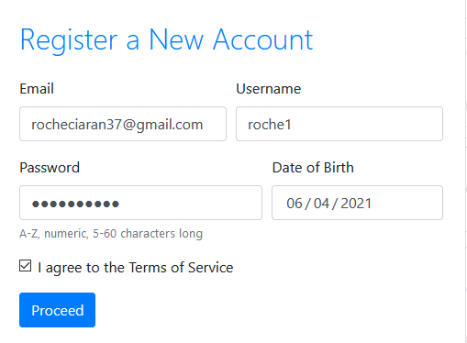

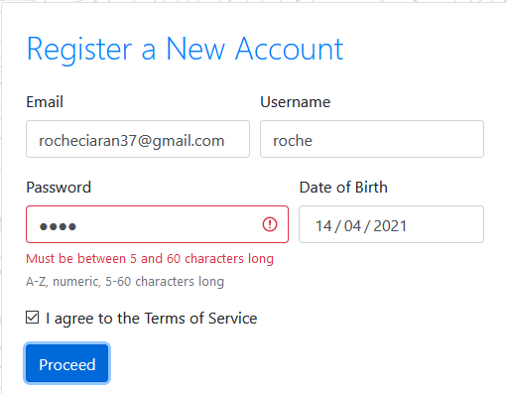

Invalid password

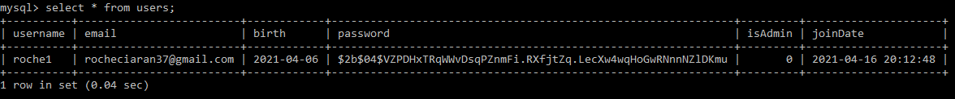

Registered user in database.

***Login:***

The next feature is the login page. The user has just registered their account. They may now navigate to the login page. Here they will be asked to enter their email and password. The user must provide the correct details in order to successfully login. Below is a couple of screenshots of our login system.

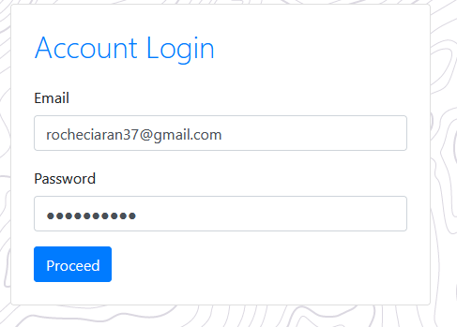

***Home Page:***

The Home page is the users landing page once they are successfully logged into the account. Here the user can see all the relevant information to them. The first section of the page is a list of the months most rated deli places. The second section is for newest reviews. These will dynamically update as new reviews are added to the list. Below is a couple of screenshots of the home page.

*Screenshots*

***Post Review:***

This is the page where a user can submit a review for a deli. The user is required to enter the deli name and enter details about their review. There is a grey button labelled browse. The user can use this button to upload pictures from the deli they are rating. Finally, the user is able to give a star rating. The higher the rating the better for the deli! Below is a screenshot of the page.

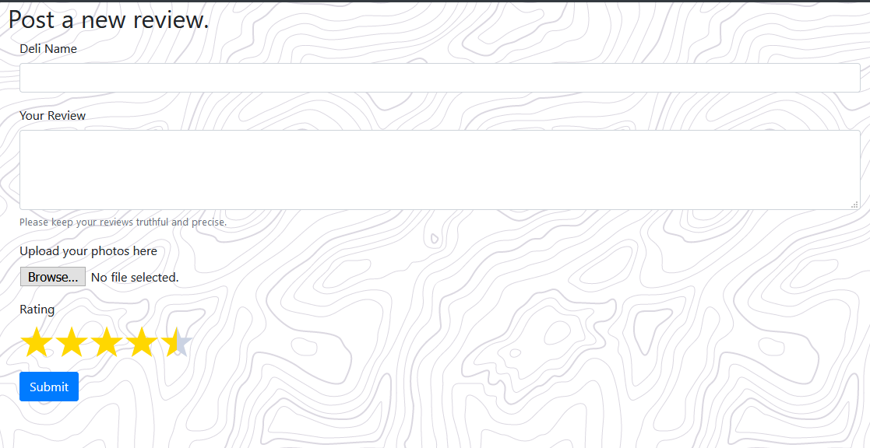

***Map Page:***

The map page is used as a tool for the user to navigate and find different and nearby delis. Any deli that has been rated or added to the database, will appear on the map. This allows the user to find delis with ease and decide by the reviews if they would like to try it. The user can also search for a deli on this page. Below is a screenshot of the map page.

*Screenshots*

***Navigation Bar:***

The navigation bar is a feature we have implemented that can be seen at the very top of the application. This allows the user to navigate around the website with efficiency and ease. The Links on the navigation bar bring the user to the different pages on the application.

**

**Limitations and Known Bugs:**

**Testing Plans:**

**Recommendations for Future Development:**

There are a number of different ways on which we can enhance the project as follows:

On the front end of the application, we can always make the design more modern, sleek and eye catching for the user. At the moment we are very happy with the design, however, in future we may decide that we would like to change the colour scheme. This is easily done but for the moment and sake of the project it was not necessary. We can also add new features in the future. We will undoubtedly have new ideas that we would like to add or pursue and would be a fun way to pass time.

On the database end we can always add more tables. This of course will depend on us adding new features to the website.

We can always look at expanding the website. In the future we don’t necessarily have to limit it to chicken rolls or delis. It is an area that has a wide variety and so many different types of cuisines out there. For example, we can always adopt an approach at looking at restaurants and rating their meals etc.

In terms of software, there is always a possibility for upgrading our code per say. There may be an efficient new way at doing things that we discover and may decide to adopt that into our project.

**Conclusions - what you learned from this project:**